Assignment-4

Create a git repo and add 3 branches to it, add index.html to each branch. Create 3 slave machines s1q1, s2q2, s3q3. Whenever there are any changes in branch or any new commit happens to branch that specific Jenkins-job should be triggered automatically on that specific slave machine.

- Created git repo and 3 branches
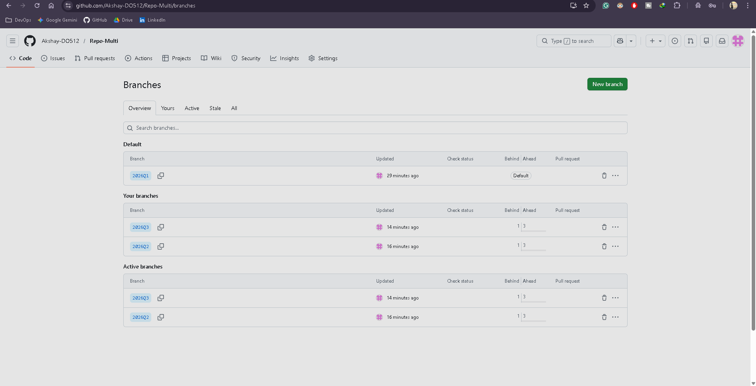

- Created 3 slave machines
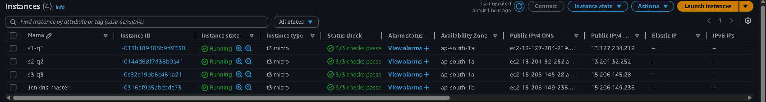

- Added the slave machines as node on Jenkins
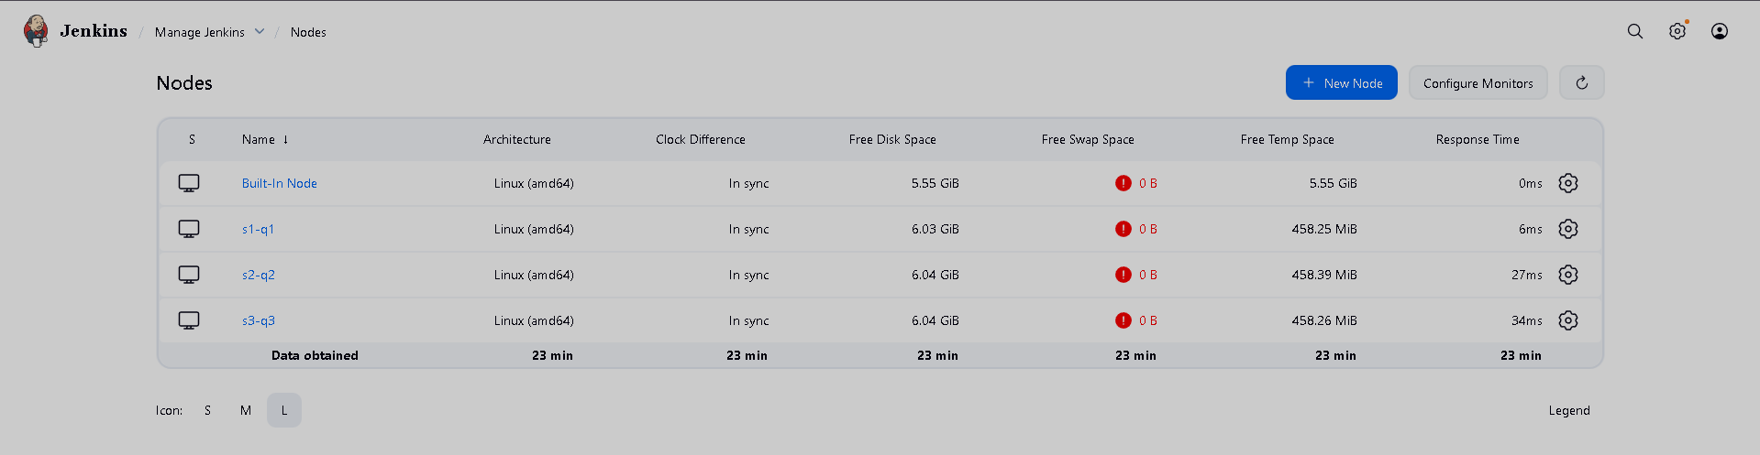

- Setup connection between git and Jenkins for build triggers
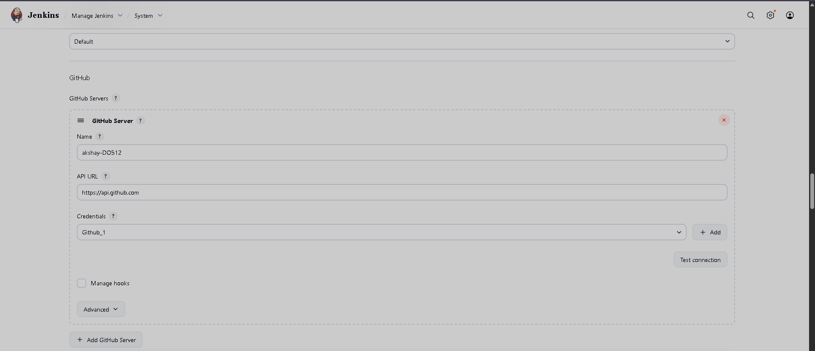
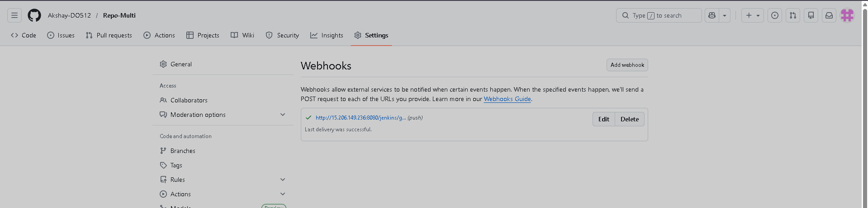

- Jenkins Job configuration
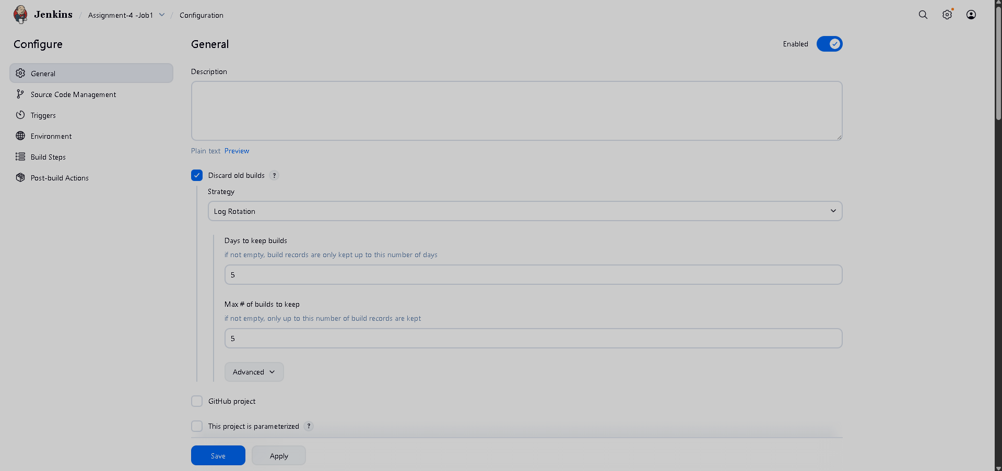
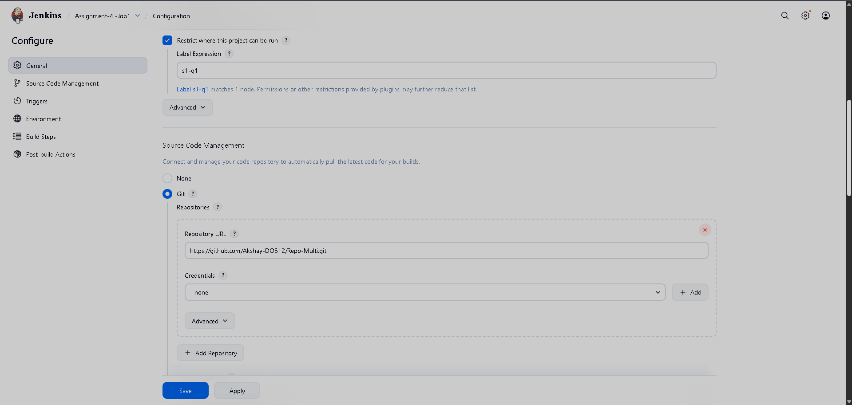
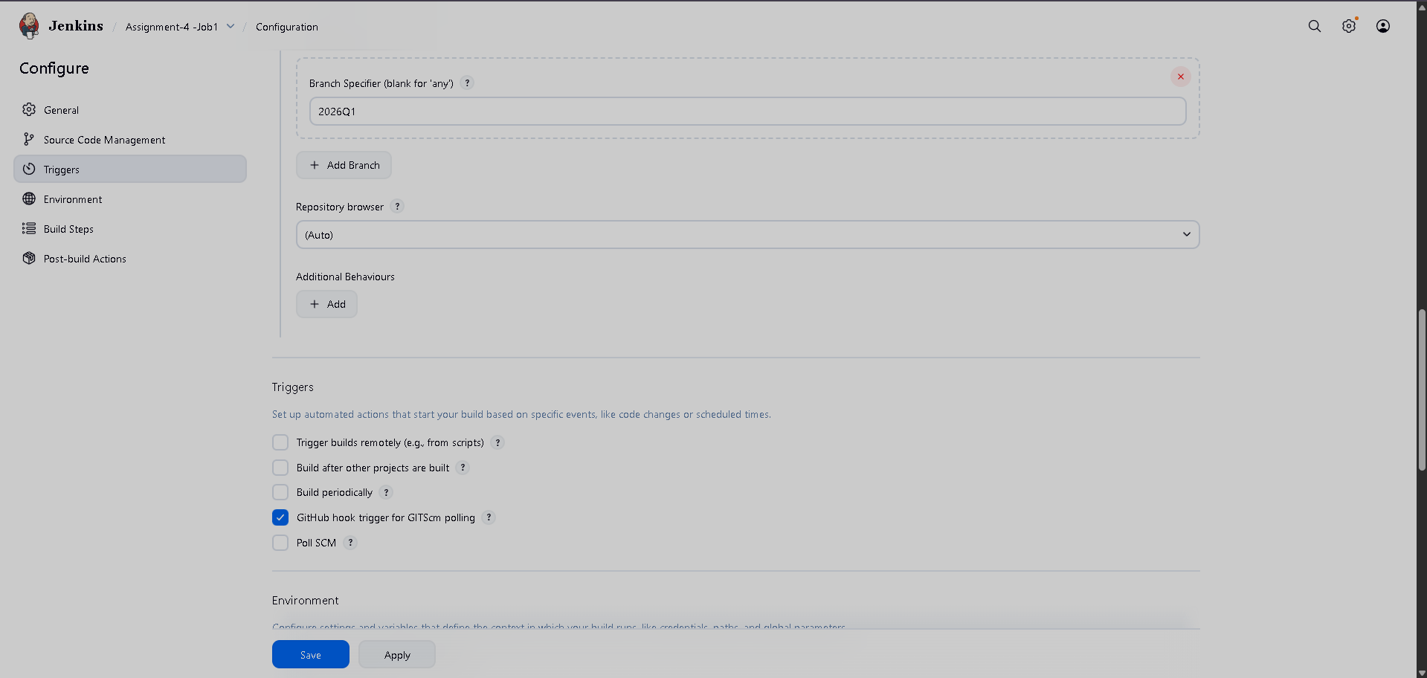
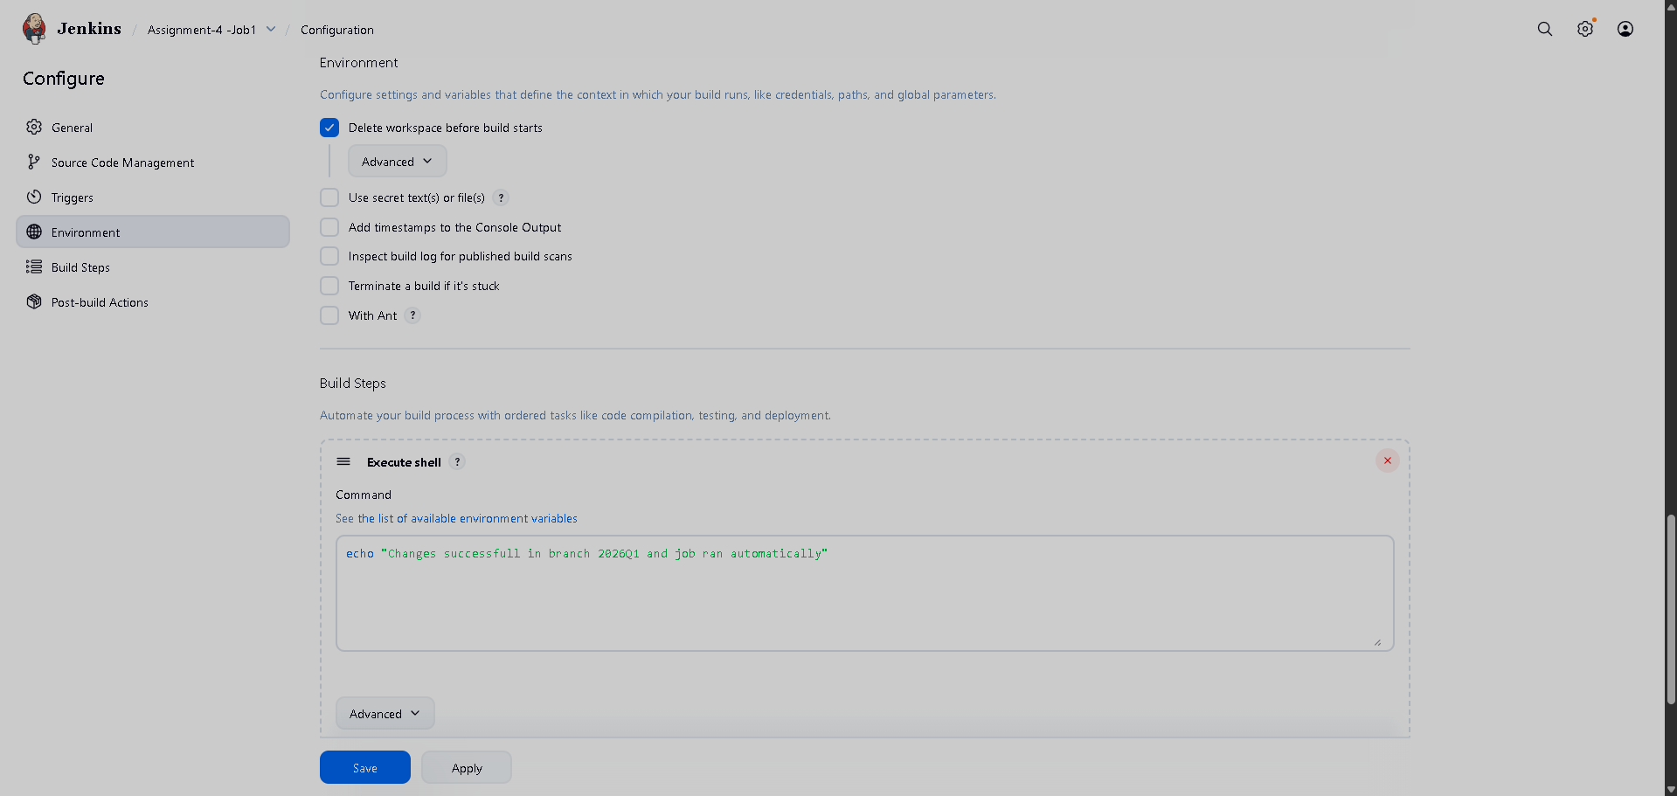

- Setup 3 jobs similar to above
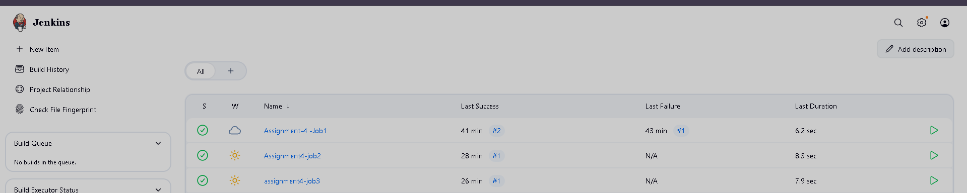

- Committed new changes to index.html file and the job triggered based on changes.
